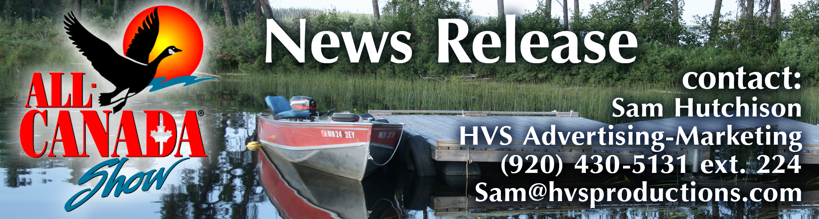
November 27, 2019
FOR IMMEDIATE RELEASE

All-Canada Show returns to Chicago
The 37th annual All-Canada Show – visiting Chicago, Thursday-Sunday, Jan. 9-12 at the Pheasant Run Resort in St. Charles – returns featuring Canada’s best fishing and hunting destinations. The event also includes: free seminars, free maps and travel guides and, on opening night every guest receives a free Dardevle 2020 collector lure.
Representatives from Canada’s best fishing and hunting lodges, resorts and outfitters are the main attraction at the All-Canada Show, offering guests a chance to meet with them face-to-face before deciding on a destination. In addition, the show’s traditional favorites are back, including an authentic Canadian shore lunch (for an extra fee) in concessions, featuring Labatt Blue.
New at this year’s All-Canada Show in Chicago:
- 360 Adventure. It’s an interactive float plane simulator. Strap on the virtual reality goggles and take a four-minute flight into a remote Canadian lake in this interactive experience, available only at the All-Canada Show.
- Blizzard of Fish. Step inside the booth and grab as many flying fish as you can. You could win an instant prize, or catch the largest of one of five fish species and win the top prize for the show!
- Friday Night Beer Night. Featuring a sampling of 3oz Labatt Blue beer samples.
Seminars headlining the 2020 All-Canada Show in Chicago include:
Jim Saric, Musky Expert—A Legendary Angler in the Freshwater Fishing Hall of Fame, Saric is Host and Executive Producer of The Musky Hunter television series, Editor at Large of Musky Hunter Magazine, and a seven-time musky tournament winner. Jim is a contributing writer for In-Fisherman, North American Fisherman and Fishing Facts magazines; and has a monthly column in Midwest Outdoors Magazine. He has produced 13 highly acclaimed musky videos, co-authored the book “The Complete Guide to Musky Hunting” and recently released “Muskies My Way.” Saric’s seminar: "Canadian Musky Strategies."
Chase Parsons, The Next Bite TV—As a professional walleye tournament angler, Chase Parsons has made an impressive imprint on the fishing industry throughout his career. Chase is a frequent host of "The Next Bite" television show, which airs on NBC Sports Network, Destination America and WFN. Chase’s seminars: “Canadian Walleye Tips”
Jim Crowley, Hook & Hunt TV—Jim has fished in Canada, the Caribbean, the Atlantic, the Pacific and throughout the Midwest. As an outdoor writer, photographer and traveler, he has fished extensively in Ontario, Saskatchewan and Manitoba. Crowley’s seminars: “Power Presentations for Big Smallmouth”/ “Small Details for Monster Pike.”
Tyler Trampe, Professional Guide, Host of “Sportsman’s Journal”— The popular Fox Sports Net television series follows Tyler and his wife, Sara, on their fishing adventures across
Northwest Ontario and the Midwest. Known for his ability to read "difficult" water and translate
(continued…)
those tactics for others has propelled his career from guiding in northern Wisconsin in his early 20's to operating three Canadian fishing resorts by age 30. Tyler has been featured in numerous magazine articles, books and multiple web-based publications. Trampe’s seminar: “Vertical Jigging For Walleyes.”
Favorite attractions returning to the All-Canada Show include:
- Trip Giveaways—two fantastic Canadian fishing trips will be given away in Chicago (in addition to the Grand Prize trip), with the help of local media outlets and social media. Check AllCanada.com for details.
- Grand prize is a fantastic trip for two to Gangler’s North Seal River Lodge in Northwest Manitoba. The winner and a guest will fly out of Winnipeg, Manitoba, directly to the lodge. Total retail value: over $15,000.
- Canada Questions Booth featuring the All-Canada Show Pro-Staff – For any show guests with questions about how to plan the perfect Canadian adventure, this is a great place to start. Anyone is welcome to stop by to chat, ask questions about packing, border crossing, travel, lodge package options, fish and game species, or just to how to book your trip right at the show. The Pro Staff spends much of the year crisscrossing Canada and love to talk about it!
- All-Canada Show Photo Booth – Show guests can hug a black bear, mug with a Mountie, hold that fish of a lifetime, goof off with fellow adventurers…all captured for friends and fans with a Canadian selfie in this interactive Photo booth.
Other All-Canada Show attractions include:
Meet A Top 10 Wildlife Artist—Anthony J. Padgett, rated in the top 10 wildlife artists in the United States, will be present during all show hours in the Anthony Padgett Gallery at the show.
“YOU BOOK IT WE BUY IT”—anyone who books a Canadian vacation at the show becomes eligible to have it paid for by the All-Canada Show in our “You Book It, We Buy It” promotion.
Dardevle Night—Opening night (Thu., Jan. 9) every show guest will receive a free Dardevle 2020 collector lure. Kids 17 and under will receive the same free collector lure during all show hours.
Kids Area – Kids are invited to decorate their 2020 collector fish. Throughout the show, all kids under 12 receive a free wooden fish at the door. They can decorate it in the “Kids Fish Zone”!
Admission--Adults, $12; children 17 and under, free. Veterans admission free on Sunday (Jan. 12). Parking: free. Discounted tickets ($9) are available online (AllCanada.com).
Show Location: Pheasant Run Mega Center, 4051 East Main Street, St. Charles.
Show Hours: 5-9 p.m. Thursday; 3-9 p.m. Friday; 10 a.m.-6 p.m., Saturday and 10 a.m.-4 p.m., Sunday.
Sponsors—All-Canada Show sponsors include:
- Yamaha ATV/UTV/SSV of Canada
- Lund Boats
- Mercury Marine
- Labatt Blue
- Dardevle Lures
LIKE on Facebook: AllCanadaShow
Follow on Twitter: @allcanadashow
Follow on Instagram: @allcanadashow

For show details including a complete seminar speaker lineup visit: www.AllCanada.com.
-end-

